

Single Point of Access (SPA)
School Public Health Service
Maidstone Studios
Vinters Business Park
New Cut Road
Maidstone
ME14 5NZ

Phone: 0800 011 3474
Email: nem-tr.kentchildrenandyoungpeoplehealthservices@nhs.net
Web: https://www.kentcht.nhs.uk/

Dear Head teacher,

Kent Community Health Foundation Trust (KCHFT) has added an additional way for parents and others to contact the school health team.

The emotional health consultation line will support parents and carers who have concerns about their children’s emotional wellbeing. Parents can speak to a trained school nurse and get immediate strategies to support their child or be referred for ongoing support or counselling if needed.

This is in response to the increased anxiety that many families are experiencing. Please use the below copy in school newsletters, website/social media channels and Covid communications to promote this offer.

Visit www.kentcht.nhs.uk/service/school-health/education-support/ or call 0800 011 3474 for more information on the support available to schools, families and young people from the school health service.

Have you noticed a change in your child’s behaviour and worried they may be experiencing anxiety?

They may be

- finding it hard to concentrate
- having trouble sleeping and/ or a change in appetite
- seeking constant reassurance
- feeling nervous or on edge.

If you feel your child is struggling and needs extra support, call the emotional health consultation line on 0800 011 3474 to speak to our team (option 1 then option 2). A school nurse will listen to you, provide basic coping strategies and if needed, support with a referral to the children and young people’s (CYP) counselling service. Young people are also welcome to call the consultation line themselves, or if they prefer, they can text in confidence by text, through our ChatHealth service on 07520 618850 (monitored 9am-5pm Monday to Friday)

Kent Community Health Foundation Trust (KCHFT) provides support for children and young people’s physical and emotional health needs, including the CYP’s counselling service.

More information on all our support can be found at www.kentcht.nhs.uk/service/school-health or www.kentyouthhealth.nhs.uk.

Alison Watkins
Team Coordinator of SPA
School Health Service
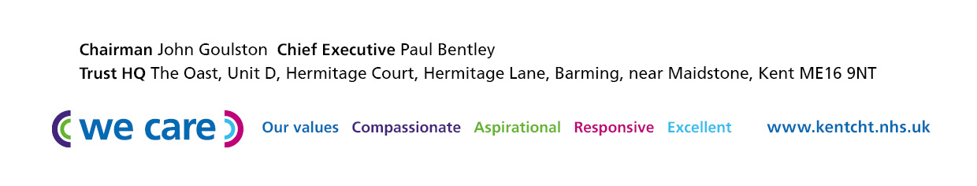
Children and Young People Directorate

Do you have feedback about our health services?  Phone: 0300 123 1807  8am to 5pm, Monday to Friday  Text: 07899 903499  Email: kentchft.PALS@nhs.net  Web: www.kentcht.nhs.uk/PALS  If you need to speak to someone  about your appointment, please  contact the service directly using the  details at the top of page one. |   Patient Advice and Liaison  Service (PALS)  Kent Community Health NHS  Foundation Trust  Unit J, Concept Court  Shearway Business Park  Folkestone  Kent CT19 4RJ

