8th October 2021
Dear Parents/Carers,
As planned, I am writing to provide you with an update on the school’s current closure. It is our intention to fully re-open the school for Face-to-Face teaching on Monday, October 11th. The vast majority of staff who have had COVID are now out of quarantine making this decision possible. I would like to take the opportunity in this communication to recognise their tireless work over the past eight academic days to support our children and young people. Their contributions have been outstanding.
Over the final two weeks of term we will be putting in some extra precautions to prevent further outbreaks of COVID. All staff meetings will be via TEAMS and staff movement between the lower/middle and upper schools will be restricted. Staff and students will be encouraged to wear masks although that will be a personal choice. As we have done so far this term, breakfasts and lunches will be served in classrooms.
We would like to take the opportunity to thank you for your support and patience during a difficult period for our school community.
I hope that you and your family are well
Take care and best wishes,
Mr T Neave

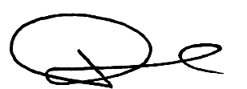
Executive Headteacher

