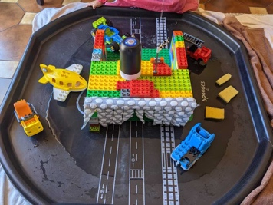
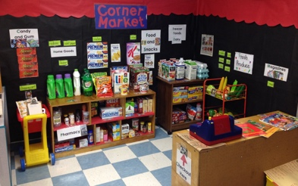

The Environment
- The learning environment should encourage active learning, interaction and independence
- The learning environment needs to be kept organised tidy, large baskets can be used to collect resources if they need gathering quickly. Resources should be labelled clearly with appropriate symbols, pictures and words
- Teachers must plan to resource environments that cater for focussed learning intentions and individual outcomes
- Opportunities for children to practise what they have learnt should be available in the environment
- The interests of the children should be taken into account when planning resources based on previous engagement observations
- Environments should encourage independence and functional skills
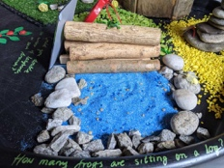
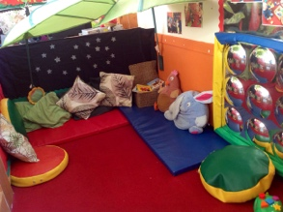
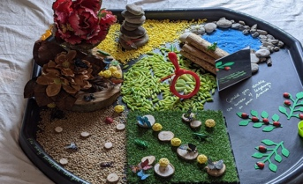
- Environments should aim to create comfortable, safe and homely environments. Each class should include a reading / cosy area, role-play, tuff spot, ‘den’, tent or quiet space.

The role of the Adult

- To form close relationships with the children using the Protect, Relate, Regulate and Reflect (PRRR) model, making them feel valued and respected
- To inspire
- To nurture
- To model strategies of self – regulation and use of the zones of regulation
- To respond to and be sensitive to the interests of the children
- To regularly observe, assess and plan for learning
- To plan an effective learning environment
- To be a positive role model and model curiosity, perseverance, initiation and exploration

Social, Emotional and Mental Health at Elms
Reception to Year 4
 | Self- regulation | Managing Self | Building Relationships
Stepping Stone 1 | - May find ways to calm themselves through being comforted by their key person or an item that is important to them  - Begin to understand they are in control of and responsible for their own behaviour and learning (this does not mean that they are necessarily able to manage their own behaviour without support)  - Shows an awareness of the Zone of Regulation and may indicate a colour to represent how they are feeling | - May check in with their key person at times throughout the day for reassurance  - Develop confidence by trying new things with the support of a trusted person  - Developing the ability to transition to some frequently visited places within the school calmly | - Enjoys spending time with and interacting with familiar adults  - Engages with adults with adults to achieve a goal  - Allows an adult to play alongside them when playing with a toy or resource and may tolerate mirroring  - Plays with confidence on their own and alongside other children  - They treat living things with care and concern
Stepping Stone 2 | - Recognises the emotions ‘happy’ ‘sad’ ‘angry’  - Begin to show ‘effotful control’ when waiting for a turn / resisting a strong impulse to grab what they want or push their way to the front  - Begin to recognise their behaviours linked with which zone they are in | - Broaden interests and are able to choose from and engage in a wider range or resources and activities available  - Can smoothly transition around to different places in the school  - Begin to show awareness of appropriate behaviour in social situations | - Pays attention when engaging with adults, looking for clues about how to respond  - Allows and adult to ahre or take turns with a toy / resource they are playing with  - Begin to show an interest in what others are doing (my be from afar)
Stepping Stone 3 | - Talks about their feelings using words like ‘happy’ ‘sad ‘angry’ ‘scared’ or ‘worried’  - Beginning to show understanding of how others are feeling; for example looking at their face as a cue  - They show a basic understanding of what is right and wrong in familiar situations | - Develop their sense of responsibility and membership of a community for example carrying out tasks such as helping with the lunches  - Can transition to less familiar places smoothly with the support of trusted adults and visual supports / preparation | - Enjoys the company of other children and sometimes wants to play with them  - May try and initiate play in their own way for example checking behind them to see if they are being chased in ‘tag’  - May engage in games involving physical contact such as ‘ring a roses’ or ‘hokey cokey’  - Can share toys with peers most of the time with visual or verbal reminders  - Engage with visitors or unfamiliar people for example by saying ‘hello’
Stepping Stone 4 | - They understand agreed codes of behaviour which help groups of people work together  - Demonstrate an increased understanding that they can help themselves to regulate  - Begin to judge right and wrong on the basis of their consequences of their actions | - Show resilience and perseverance in the face of challenge  - Follows and shows an understanding of why rules are important  - Develops confidence when exploring a range of different places during off-site visits  - Has an awareness of their own safety in the community and around roads | - Develops friendships with peers  - May copy peer’ actions  - Develops ability to play attachment games such as ‘hide and seek’, ‘duck, duck, goose’  - Developing turn taking during structured activities
Stepping Stone 5 | - They understand agreed codes of behaviour which help groups of people work together and support others in behaving appropriately  - Begin to moderate own emotions in the face of frustrations  - Increasingly able to talk about a range of strategies available to help themselves to calm  - Consider the feelings of others and offer comfort  - Recognise personal achievements | - Develop appropriate ways of being assertive  - Sees themselves as a valuable individual  - Remembers rules without needing an adult to prompt them  - Develops an understanding of what it means to be a safe pedestrian  - Shows confidence when trying new activities with resilience and perseverance in the face of challenge | - Froms positive attachments to adults and friendships with peers  - Builds constructive, respectful relationships  - Plays with one or more children, extending and elaborating on play ideas  - Works and plays co-operatively  - Finds solutions to conflicts
Stepping Stone 6 | - Think about the perspectives of others  - Begin to access their range of effective strategies to regulate  - Set and work towards simple goals, being able to wait for what they want and control immediate impulses  - Respond appropriately when attending to an adult even when engaged in an activity  - Show an ability to follow instructions involving several ideas | - Demonstrates an increased understanding and ability to conform to appropriate behaviour when out in the community and social situations  - Develops a secure understanding of the dangers and importance of staying safe near roads – can talk about road safety and takes responsibility for keeping safe  - Can explain the reasons for rules, knows right from wrongs and tries to behave accordingly | - Shows sensitivity to their own and the needs of others’
Physical and Sensory at Elms

Reception to Year 4

 | Gross Motor Skills | Fine Motor Skills | Sensory and self – care
Stepping stone 1 | - May clap or stamp to music  - Enjoys kicking, throwing and catching balls  - Builds independently with a range of appropriate resources  - Can use a scooter or push themselves on a tricycle  - Explores climbing equipment such as ladders or steps  - Can independently walk along a bench  - Uses large muscle movements to wave flags and streamers, paint and make marks | - Can scoop materials using tools  - Develops use of tools and utensils in a rnage of situations such as mixing using a wooden spoon  - Develops control when using mark making tools for example tracing and copying  - Develops manipulation and control for exmaple rolling sausage shapes | - Enjoys activites such as swimming, using watering cans, emptying containers  - Begins to explore a wider range of food types for example feeling with hands, licking, smelling  - Begin to use specific sensory diet equipment highlighted to support individual needs for example using a trampet when prompted, wearing ear defenders for short periods of time  - Allows an adult to briefly brush teeth  - Can pull trousers up/ down
Stepping stone 2 | - Develops coordination when throwing / kickoing balls  - Develops riding skills when using scooters / bikes  - Develops confidence and skills when using unfamiliar climbing equipment  - Can walk down a narrow balance beam  - Skips, hops, stands on one leg and can hold a pose for example in musical statues | - Chooses the right resources to carry out a plan for example choosing a small bucket  - Explores different writing tools  - Develops and refines skills such as pouring, stirring, building with connecting blocks, threading activities, making snips with scissors, spreading / chopping with a knife, manipulating playdough using hands and tools to create simple models | - Grows in confidence when exploring wet materials  - Can follow a sensory diet with increasing independence  - Begins to brush own hair  - Allows an adult to brush their teeth for a longer time  - Takes part in care – related role-play  - Uses a fork to pick up food  - Can put on own shoes  - Can put on own coat
Stepping stone 3 | - Match their developing physical skills to tasks and activities within the setting  - Is able to walk and climb on more complex equipment such as climbing walls  - Further develops ball skills including aiming, passing and batting  - Combine different movements with fluencyfor example in an obstacle course  - Increasingly be able to use and remember sequences and patterns of movements which may be related to music | - Use fine motor skills to do things independently for example pulling up zip, undoing buttons  - Uses one handed equipment  - Has a comfortable grip when using pens and pencils  - Shows a preference for a dominant hand | - Begin to develop an understanding of their own sensory needs for example beginning to recognise when they may need to use sensory diet equipment  - Brushes own teeth  - Is increasingly independent getting dressed and undressed  - Makes some healthy choices about food and drink
Stepping stone 4 | - Confidently and safely uses a range of equipment large and small  - Develops precision and accuracy and competence when engaging in ball activities  - Takes part in group games that they make up themselves or have agreed rules  - Negotiate space and obstacles safely  - Collaborate with other to move large items | - Develop fine small motor skills to be able to use a range of small tools competently  - Holds pencil effectively with tripod grip  - Begins to deveop handwriting style theat is fast and efficient  - Shows care when drawing | - Develops the ability to manage and communicate their own sensory needs for example asking for ear defenders if the environment is too loud or helping to create their own sensory diet  - Uses cutlery safely and competently  - Independently manages dressing  - Further develops skills needed to manage the school day such as lining up

